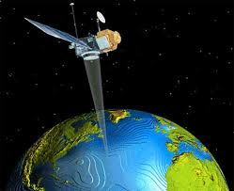
Benha University
Faculty of Engineering _Shoubra
Surveying Engineering Department
Fourth Year
Year: 2017/2018
Semester: One
Remote Sensing and Photo Interpretation
Assignment: 1

Introduction

- What is Remote Sensing?
- Types of Sensors used in Remote Sensing.
- Define the following terms:
- Electromagnetic energy.
- Reflected Radiation.
- Absorbed radiation.
- Emitted radiation.
- Transmitted radiation.
- Image interpretation.
- What are the components of real remote sensing system?
- Assume the speed of light to be 3x10⁸ m/s. If the frequency of an electromagnetic wave is 500,000 GHz (GHz = gigahertz = 10⁹ m/s), what is the wavelength of that radiation? Express your answer in micrometers (μm).
- Discuss the atmospheric influences on spectral response patterns.
- Explain the elements of image interpretation for landform identification and evaluation.
- Write in detail about the following:
- Image interpretation keys.
- Temporal aspects of photo interpretation.

